## Front End Engineering-II /Artificial

## Intelligence and Machine Learning

Project Report

Semester-IV (Batch-2022)

Shelf of Tales



**Supervised By:**   **Submitted By:**

Ms. Shagun Sharma Hiya Kashyap, 2210990415

Hunardeep Kaur, 2210990417

Illu Saini, 2210990418

Ishpreet Kaur, 2210990424

(Group-9)

**Department of Computer Science and Engineering**

## Chitkara University Institute of Engineering & Technology,

## Chitkara University, Punjab

Table of Contents

|  |  |  |
| --- | --- | --- |
| S.NO | PROGRAM TITLE | PAGE NO. |
|  | Abstract | 3 |
| 1 | Introduction | 4 - 6 |
| 1,1 | Background of the Project | 5 |
| 1,2 | Objectives | 6 |
| 1,3 | Significance | 6 |
| 2 | Problem Definition and Requirements | 7 - 9 |
| 2,1 | Problem Statement | 7 |
| 2,2 | Software Requirements | 7 |
| 2,3 | Hardware Requirements | 8 |
| 2,4 | About the Dataset | 9 |
| 3 | Methodology | 10 - 20 |
| 3,1 | Algorithm Used | 11 |
| 3,2 | File Structure | 12 |
| 3,3 | Schematic Diagram | 16 |
| 4 | Result | 17 - 26 |
| 4,1 | Data Description | 17 |
| 4,2 | Analysis Methodology | 18 |
| 4,3 | Exploratory Data Analysis | 20 |
| 4,4 | Deployment | 22 |
| 4,5 | Conclusion | 24 |
| 4,6 | Future Scope | 25 |
| 4,7 | References | 26 |

Abstract

There are millions of books in the entire world wide and people need some instructions to find the appropriate book. Making decision and scrolling for the right book from millions of books can be hard and a complete waste of time. To compete and keep up in the market, some viewers may just rate the book in unbiased form. The use of such overstated descriptions is misleading the viewers to unpromising products or books. Resulting in inaccuracy of recommendation of books to the user. In this project, this problem domain has been addressed and has been tried to solve with a better approach using a collaborative filtering method. This project offers a quick and intuitive book recommendation system that enables readers to navigate and find the appropriate book to read next. The end goal of this project is to use collaborative filtering method to provide a better recommendation.pasted-image.tiff

**INTRODUCTION**

Today the World Wide Web has provided access to a vast array of information through the web pages, as a result of the Internet growth. The commercial activity on the Web has increased to the point where hundreds of new companies are adding Web pages daily. With this increase in the information sources, a problem of information overload occurs, in which the users are trying to deal with an excess of information that is not useful to them as they try to make sensible decisions. As a response to this problem, a range of tools to help with retrieving, searching, and filtering have been developed.

The benefits for the users from search engine technology have decreased as the number of web pages has grown. In addition, the user must first consider the large number of search tools available and decide which one to access. Then the user must interact with each one individually because search engines are typically not personalised to individual users or their prevailing context. Users usually make a choice on the basis of their personal experience or other people’s experience. Based on these facts, recommender systems have been developed to provide recommendations that help individual users identify content of interest by using the opinions of a community of users and/or the user’s preferences.

Today various recommendation systems play an important role in supporting commercial websites to help users find items that they know they would like to purchase, as well as discover new items about which they had been unaware. A good recommender system can significantly contribute to achieving the consumer’s acceptance of the system recommendations.pasted-image.tiff

# 1.1 Background of the project:

As the e-learning technologies is growing, searching for books on online website is also increasing in the internet these days. Finding the required information has become more difficult, as the amount of information on the internet is rapidly increasing. With the help of Recommendation system, the problem in finding the appropriate information can be solved. From movies to online shopping to music, every different services and websites uses recommendation system. For instance, Amazon uses Item-to-Item Collaborative Filtering algorithm that produces high-quality recommendations, leading to an effective personalised shopping experience for individual customer.

Basically, the idea is to analyse users pervious interaction with the items, as the past selections of item can lead to the future choice of the user, helping to recommend similar items to the user. For example, a user who is interested in reading non-fiction books may be interested to read another non-fiction book..

# 1.2 OBJECTIVES

* Recommendation systems are Artificial Intelligence based algorithms that skim through all possible options and create a customised list of items that are interesting and relevant to an individual.
* To develop a system that accurately understands user preferences and reading habits.
* To provide personalised book recommendations that enhance user satisfaction and engagement.
* To evaluate the system's performance and refine its recommendation algorithms.
* Increase user retention and revenue for online bookstores

# 1.3 SIGNIFICANCE

1. **Better Outcomes:** A robust book recommendation system has significant implications for both users and online book platforms. For users, it simplifies the process of discovering new books and enables them to explore a diverse range of titles tailored to their interests. For online book platforms, it enhances user engagement, increases sales, and fosters customer loyalty. Many companies use these systems to simply encourage engagement and activity on their product or platform.
2. **Personalised and Tailored Recommendations:** Leveraging individual-level reading history and preferences, the book recommendation system offers personalised book suggestions that align with each user's unique interests and reading habits. This tailored approach enhances the reading experience, fostering a deeper connection with books.
3. **Research and Data-driven Insights:** The data amassed and analysed by the book recommendation system contributes to advancing research in the realm of literature and reading habits. Researchers can extract valuable insights from this dataset, uncovering patterns, genre preferences, and emerging trends in reading behaviour. Such insights inform more effective book recommendation strategies and facilitate a deeper understanding of readers' preferences and behaviours.
4. **Scalability and Cost-effectiveness:** Powered by machine learning algorithms, the book recommendation system efficiently processes vast amounts of reading data, enabling widespread book suggestions at a population level. This scalability is particularly advantageous in promoting reading habits and literacy in areas with limited access to physical libraries or bookstores. By making book discovery more accessible and cost-effective, and enriches the reading experience for all users.

**2. Problem Definition and Requirements**

# 2.1 PROBLEM DEFINITION

This project aims to design and evaluate different approaches for computing recommendations within the book domain to provide personalised recommendations to the users.

Usually, people get stuck in a situation like which book to read next while many books are available in the market. Problems arise in finding similar books according to their preference due to the inadequate distribution of the books. To overcome this issue, we build a book recommendation system web application that takes the title of a book as input and gives a recommendation of the top five similar books as an output.

# 2.2 SOFTWARE REQUIREMENTS

Software Requirements specifies the logical characteristics of each interface and software components of the system. The following are some software requirements.

1. Python Programming Language: The project will be implemented using Python, which is a popular language for machine learning and data analysis tasks.

2. Python Integrated Development Environment (IDE):

• Jupyter Notebook: You also mentioned using Jupyter Notebook, which is a web-based interactive computing environment that allows you to combine code, visualizations, and narrative text.

3. Python Libraries and Frameworks:

• NumPy: For numerical computing operations.

• Pandas: For data manipulation and analysis.

• Scikit-learn: A machine learning library for Python, providing a wide range of algorithms and tools for model building, evaluation, and deployment.

• Matplotlib and Seaborn: For data visualization and plotting.

4. Version Control System: Git: A distributed version control system widely used for tracking changes in source code and collaborating on projects.

# 2.3 HARDWARE REQUIREMENTS

Hardware interfaces specify the logical characteristics of each interface between the software product and the hardware components of the system.The following are some hardware requirements.

* System : Intel Core i5.
* Hard Disk : 1 TB.
* Monitor : 15’’ LED
* Input Devices : Keyboard, Mouse
* Ram : 4 GB

# 2.4 DATASET

Dataset link : <https://www.kaggle.com/datasets/ra4u12/bookrecommendation>

The project utilises three main data sets:- BX-Books.csv, BX-Book-Ratings.csv, BX-Users.csv,

* Book metadata: This data set includes information about each book, such as ISBN (unique for each book) , title, author, publisher, publication year, Image-URL-S, mage-URL-M, Image-URL-L
* User data: This data set contains user of various books, including the user ID, Location (contains city, state a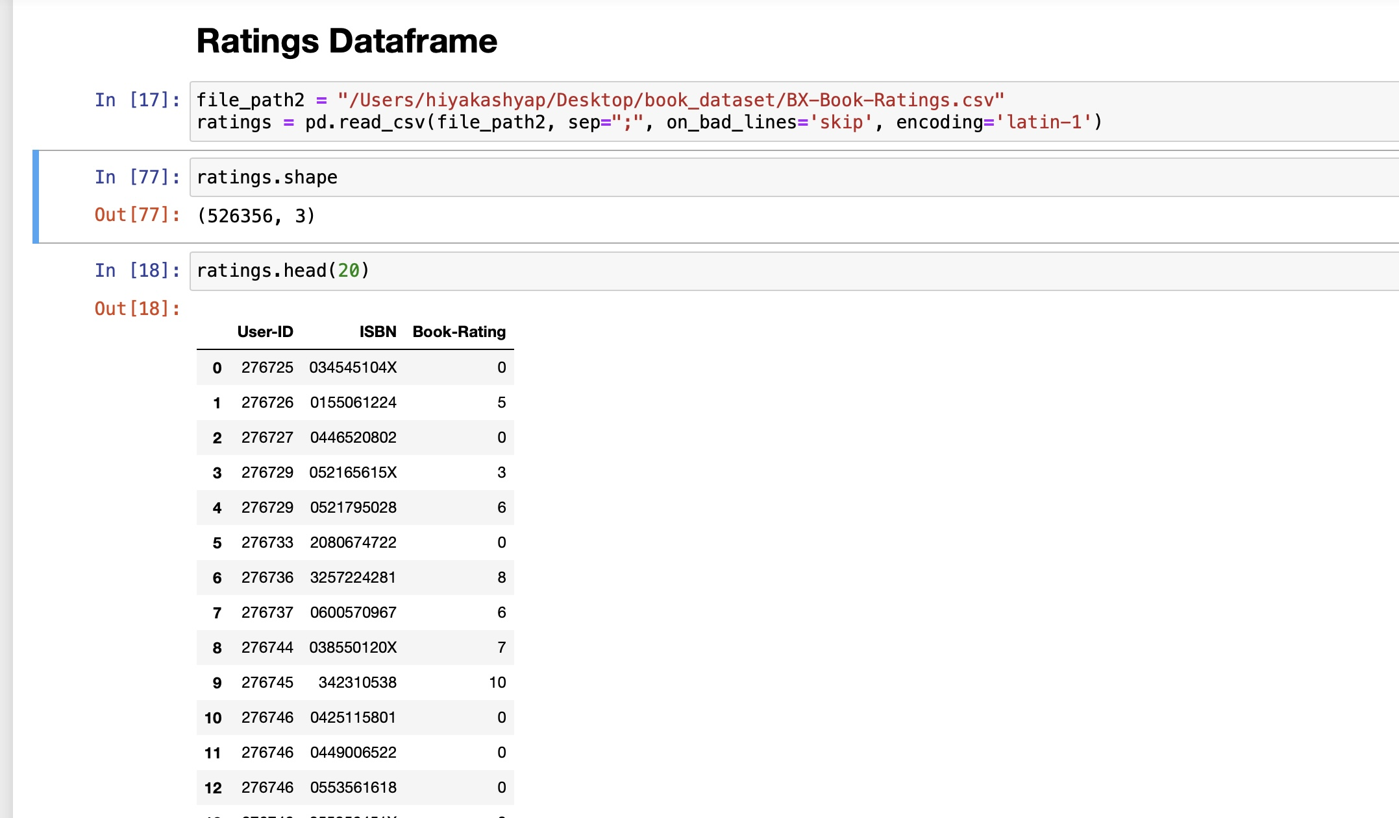nd country separated by commas) and Age
* Ratings_dataset: This data set contains user ratings for various books including User-ID, ISBN and Book-Rating.

**final_rating dataset**: This data set is a merged dat frame of all datasets which includes information about each book, author, rating, etc.

3 METHODOLOGY

In our project, we are implementing a recommender system based on collaborative filtering methodology to assist users in navigating the extensive volume of available information. Collaborative filtering serves as the backbone of our recommendation engine, leveraging collective user behaviour to generate personalised suggestions.

# 3.1 ALGORITHM USED

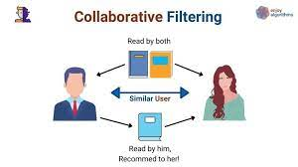

Collaborative filtering, treats users as part of a group rather than as individuals. It analyses the interactions and preferences of similar users to recommend items of interest.

**User-Based Collaborative Filtering:**

* It recommends items by finding users with similar preferences and suggesting items that they have liked
* Measure similarity between users based on their ratings
* Predict the ratings of items for the target user by taking weighted averages of ratings from similar users

**Item-Based Collaborative Filtering:**

* It recommends items by finding similar items to the ones the user has liked or interacted with
* Measure similarity between items based on the ratings given by users
* Predict the ratings of unrated items for the target user by taking ratings for similar items

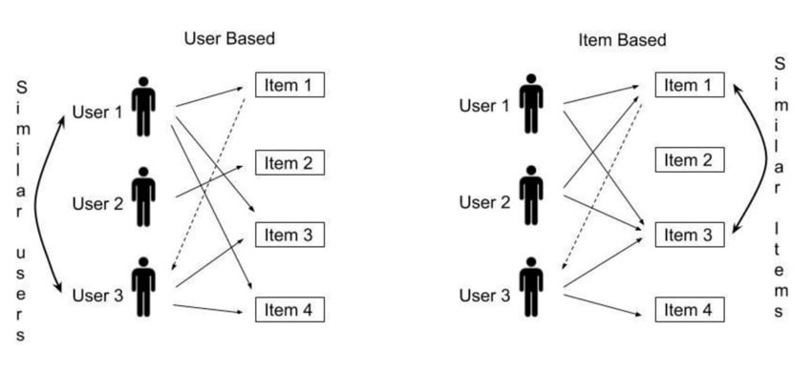

**Advantages of Collaborative Filtering**

**• Personalised Recommendations:**

By considering the preferences and behaviours of similar users, collaborative filtering generates personalised recommendations tailored to individual tastes.

* **Scalability:**

Collaborative filtering scales well with large datasets and can accommodate a growing number of users and items, ensuring robust performance in real-world scenarios.

**• Adaptability:**

The collaborative filtering approach is adaptable to evolving user preferences and changing content dynamics, providing users with relevant recommendations over time.

**• Implementation and Evaluation:**

Our implementation will focus on developing collaborative filtering algorithms that accurately capture user preferences and interactions. We will evaluate the performance of our system through metrics such as recommendation accuracy, user engagement, and computational efficiency, ensuring the effectiveness of our approach in enhancing the user experience.

# 3.2 File Structure

The project follows a modular file structure, consisting of the following main files and directories:

* data: Directory containing the raw data sets and preprocessed data files.
* notebooks: Directory containing Jupyter Notebook files for data exploration, preprocessing, model development, and evaluation.
* models: Directory containing trained model files.

Concept used to build the model.pkl file : NearestNeighbors

1 . Load the data

2 . Initialise the value of k

3 . For getting the predicted class, iterate from 1 to total number of training data points

4 . Calculate the distance between test data and each row of training data. Here we will use Euclidean distance as our distance metric since it’s the most popular method.

5 . Sort the calculated distances in ascending order based on distance values

6 . Get top k rows from the sorted array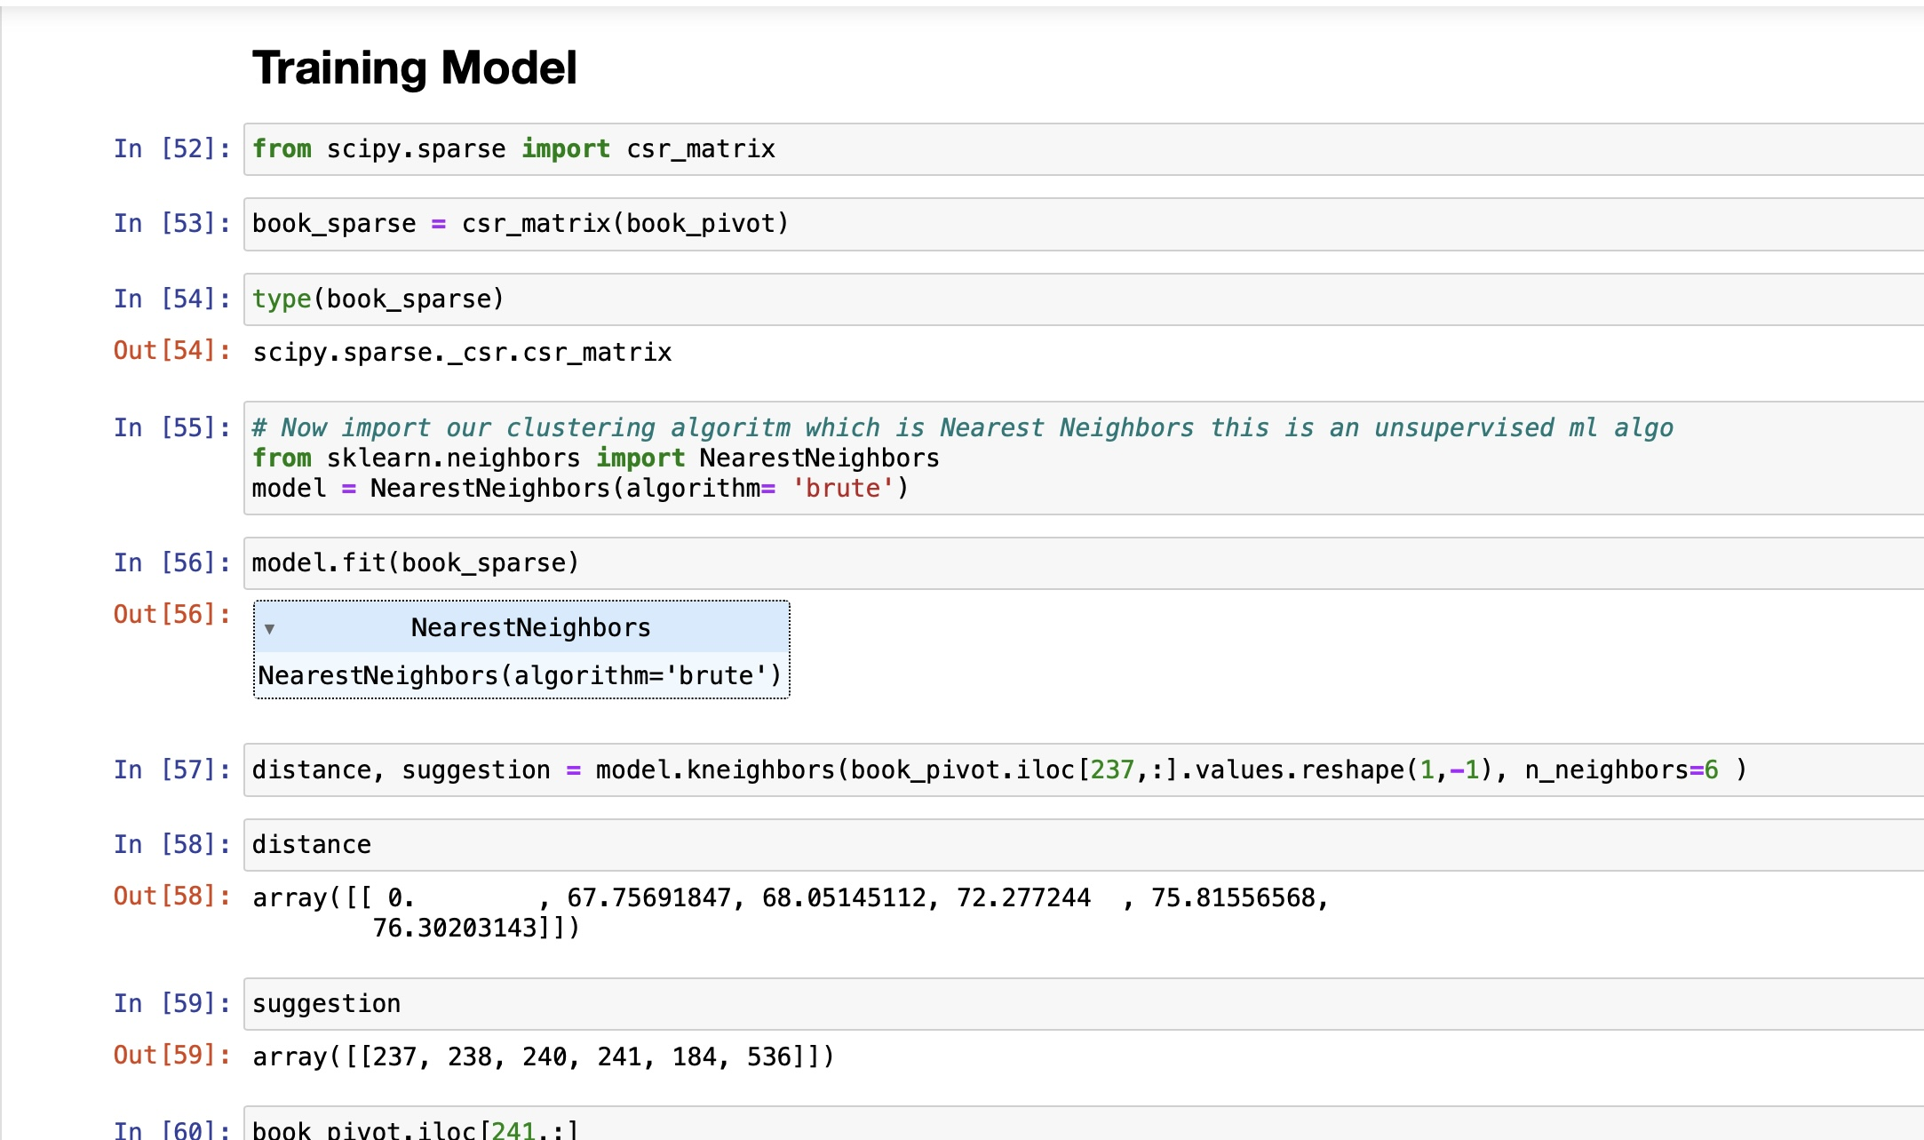

* utils: Directory containing utility functions for data preprocessing, feature engineering, and evaluation.
* requirements.txt: File listing all the required Python libraries and dependencies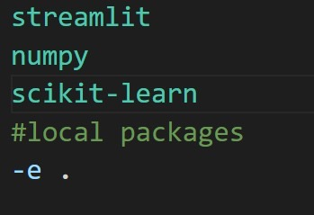
* Setup.py
* app.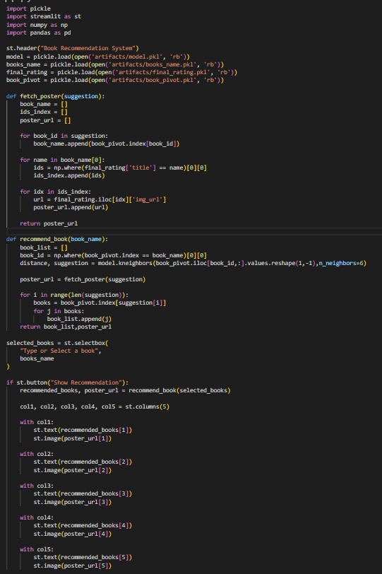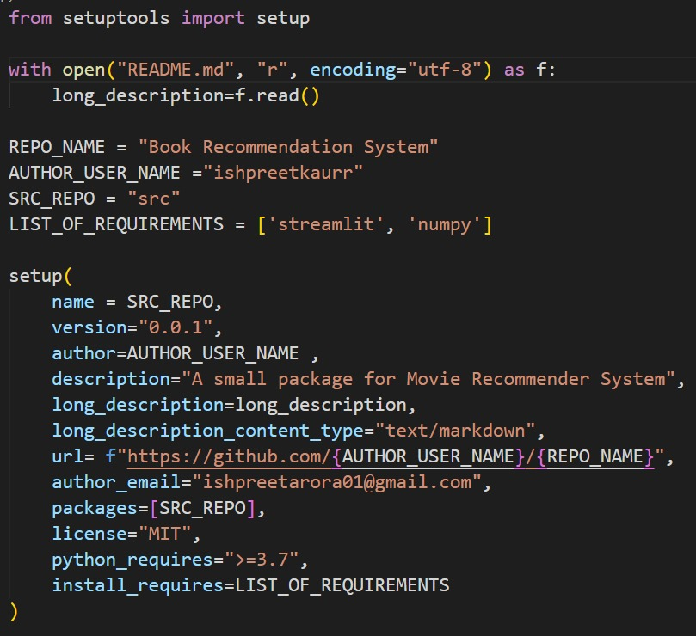py

# 3.3 SCHEMATIC DIAGRAM

1. **Data Preparation:** This involves cleaning and organizing data from Books, Books-ratings, and Users sources, addressing missing values, removing irrelevant data, and ensuring consistency in formatting.
2. **Table Fusion:** The pre-processed data from Books, Books-ratings, and Users are combined using a shared identifier such as book ID, user ID, or ISBN.
3. **Data Segmentation:** The merged data is split into a larger Training set, used for model training, and a smaller Testing set, for evaluating model performance.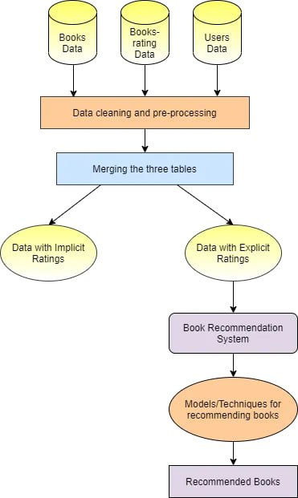
4. **Implicit Feedback Data and Explicit Feedback Data:** Utilizing implicit user interactions to enhance recommendations during model training. Incorporating direct user ratings.
5. **Recommendation Model Construction:** Building the core recommendation model using algorithms like Collaborative Filtering and Content-based Filtering to learn and suggest relevant books to users.
6. **Recommendation Techniques:** Implementing specific algorithms or methodologies tailored to available data and desired outcomes for effective book recommendations.
7. **Book Recommendations**: Delivering personalised book suggestions to users based on their past interactions and learned patterns from the recommendation model, utilizing testing or real-time user data.

4 RESULTS

The analysis aimed to assess the system's ability to provide personalised book recommendations to users based on their preferences and interactions.

# 4.1 Data Description

The analysis utilised 3 primary datasets: the user, ratings the book data. The ratings data consisted of 1149780 observations, capturing users' ratings for various books. The book metadata dataset contained information on 271360 books, including details such as title, author, and publication year. The users dataset consist of 278858 uniques user ids. All the datasets underwent preprocessing to eliminate duplicates and address missing values, ensuring the integrity of the data used for analysis.

# 4.2 Analysis Methodology

1. **Collaborative filtering** techniques leverage user-item interactions to recommend items to users with similar preferences. By analyzing patterns of user ratings across the dataset, collaborative filtering algorithms identify similarities between users or items and make recommendations based on these similarities. The collaborative filtering approach used in this analysis facilitated the generation of personalized book recommendations by identifying users with similar reading preferences and suggesting books that were well-received by those users.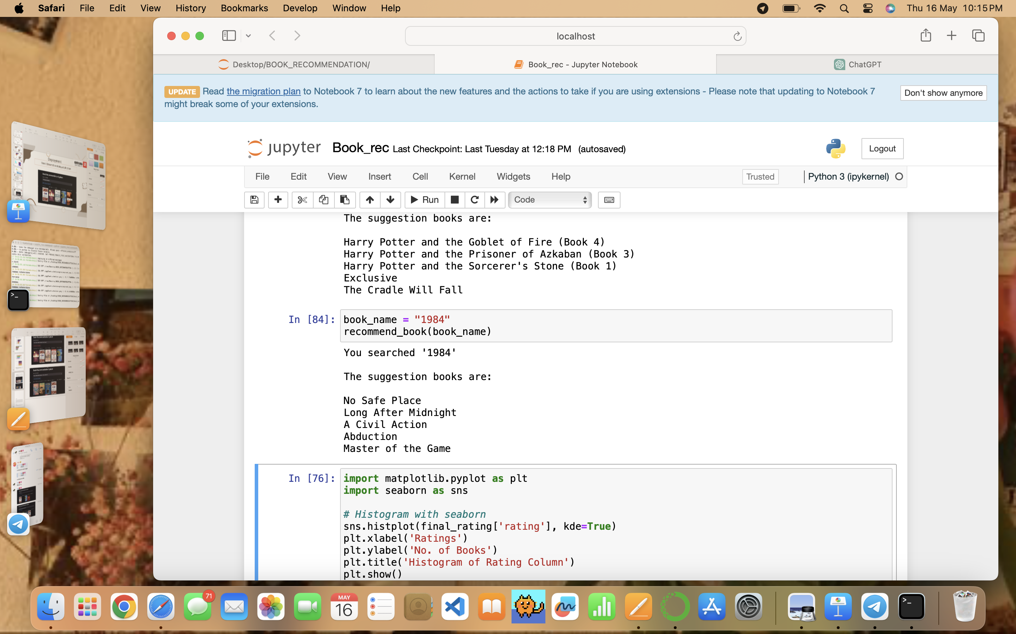

2. **Nearest Neighbour Model** was utilised to enhance the recommendation process. The nearest neighbour model identifies users or items that are closest in similarity to a target user or item. By measuring the distance or similarity between users based on their ratings or preferences, the nearest neighbour model identifies the most similar users and recommends books that they have enjoyed. This approach allows for a more fine-grained analysis of user preferences and facilitates the generation of highly personalised recommendations.



4.3 Exploratory Data Analysis (EDA)

is an essential process in data analysis that involves examining and understanding the structure, patterns, and characteristics of a dataset. It plays a crucial role in uncovering patterns, trends.

Data Inspection: This involves ex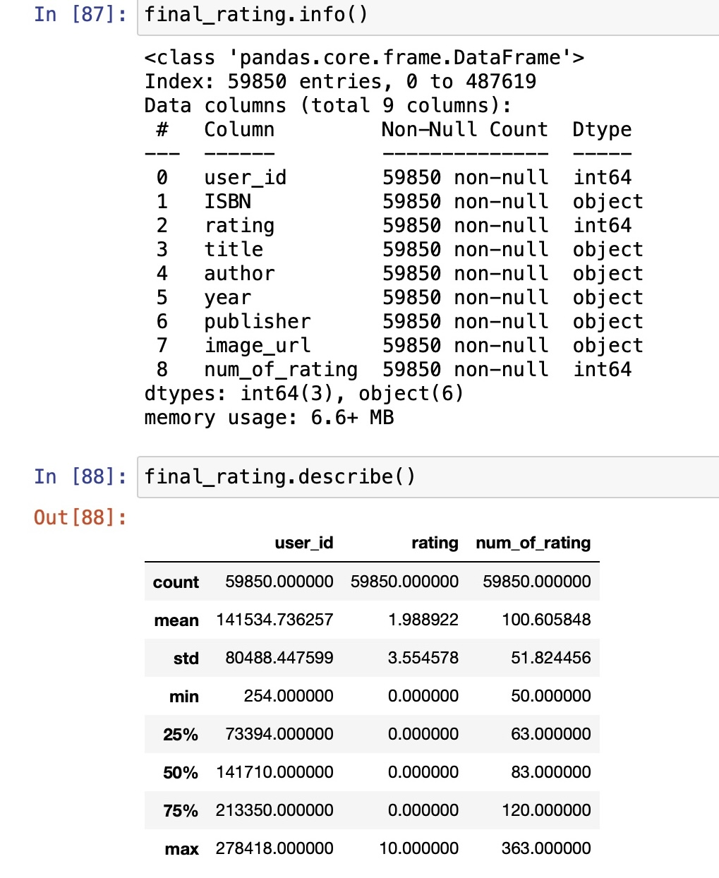amining dataset size, shape, and variable data types, while identifying missing values, outliers, and anomalies.

Summary Statistics: Calculating mean, median, mode, standard deviation, range for numerical variables, and frequency counts/proportions for categorical variables provides insights into data distribution.

Visualisation: Using plots like histograms, box plots, scatter plots, bar plots, and heat maps helps visualise patterns and relationships in the data.

The title 'Average Rating Distribution for All Books' is set, along with the x-axis label ‘Rating'. The plot shows how the average ratings of books are distributed, indicati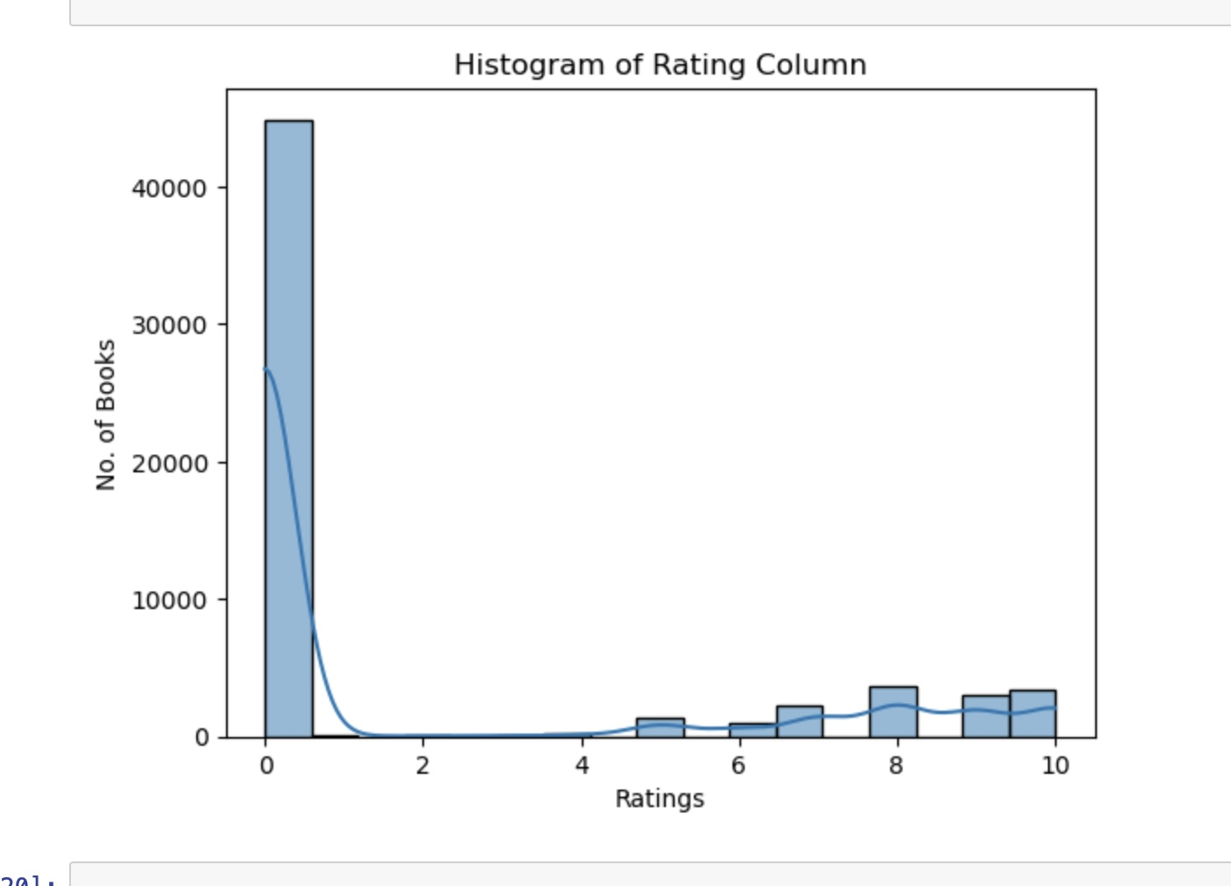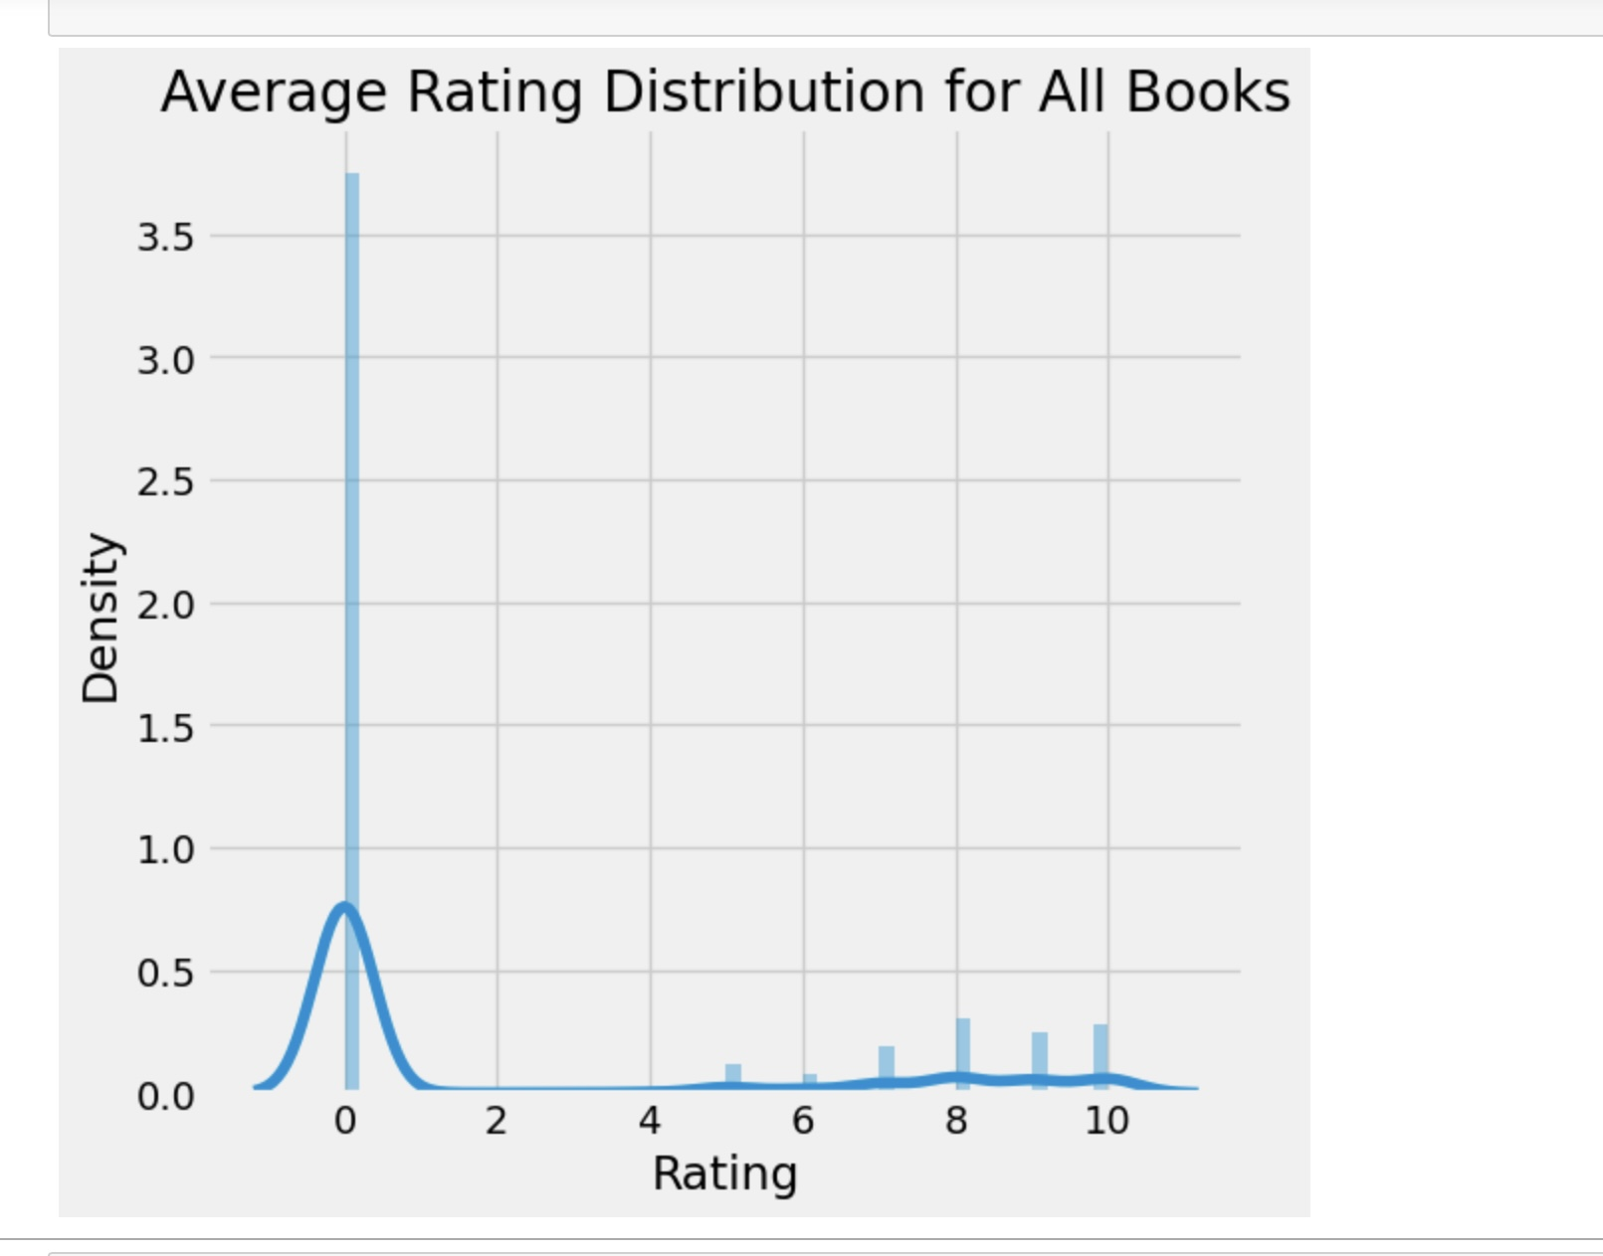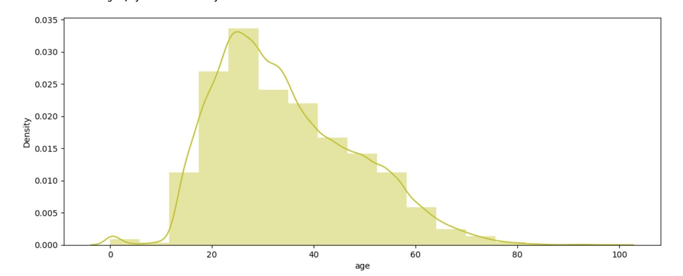ng the frequency of different rating values. Peaks in the graph suggest common rating values, while the spread indicates the variability in ratings.

Histogram: The bars in the histogram represent the frequency of books for each range of rating values. The height of each bar shows how many books fall into each rating bin. KDE Line: The smooth curve overlaying the histogram provides a continuous estimation of the rating distribution, making it easier to see the overall shape and central tendencies of the data.

**Data Analysis** such as top authors, most recommended book, highest country with maximum users, top publishers, books with highest ratings.

All graphs utilise the Seaborn countplot fun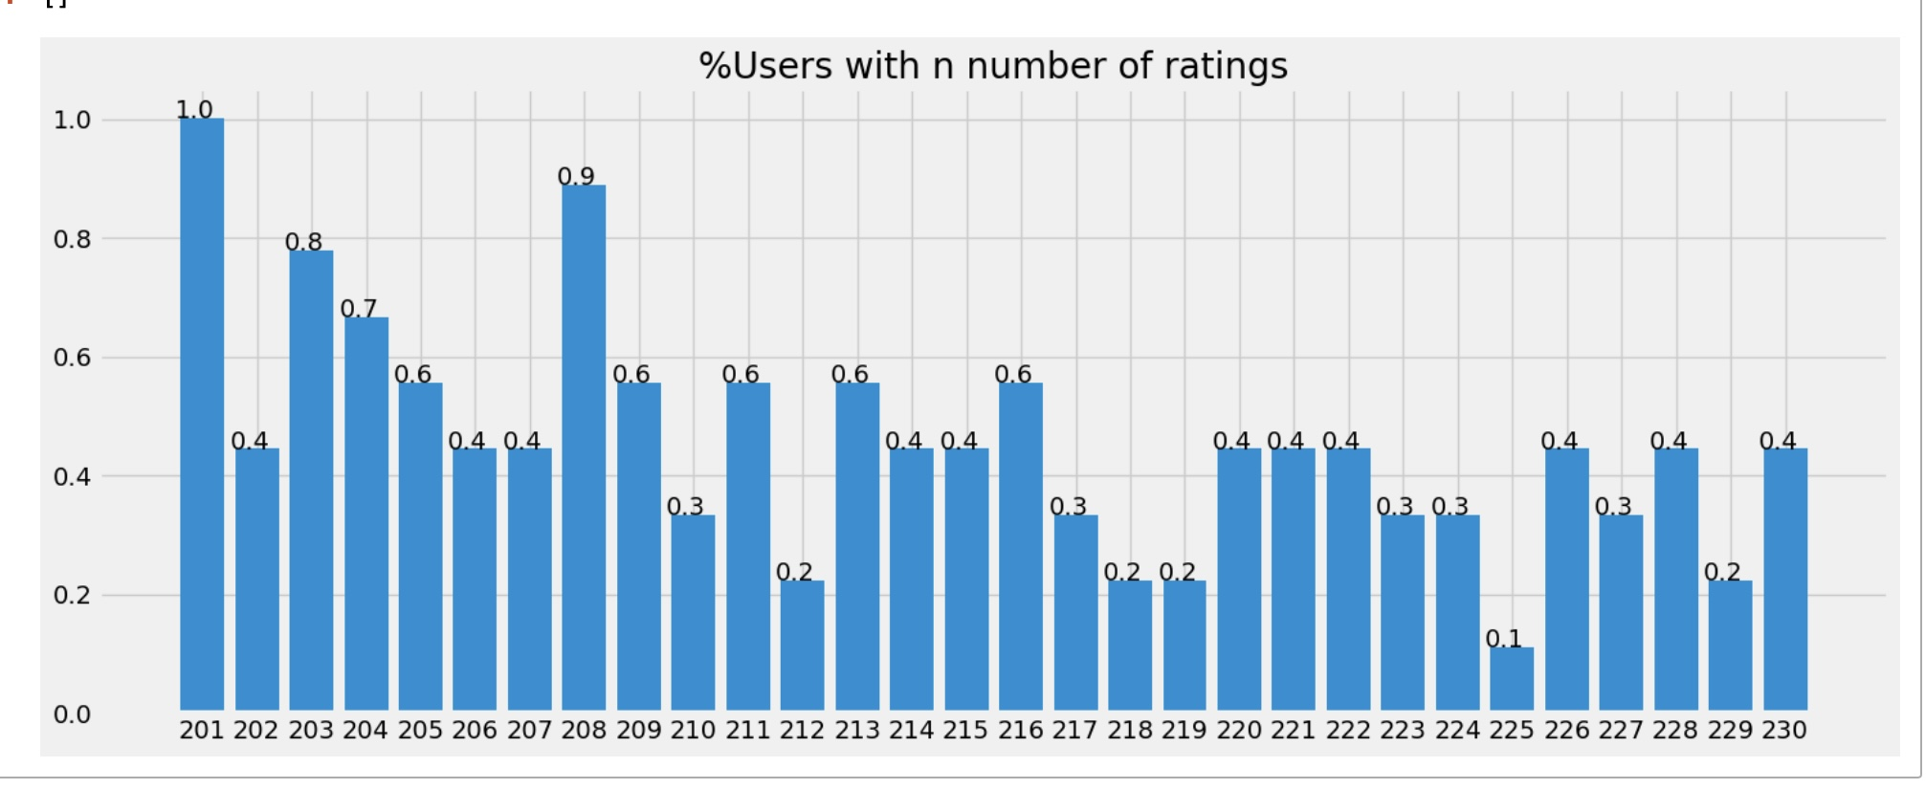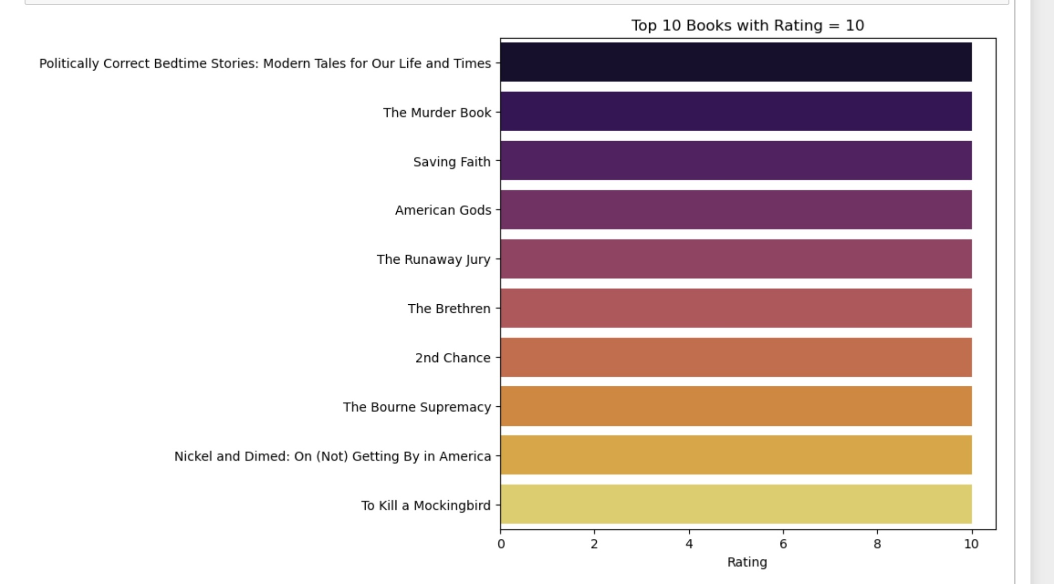ction to create horizontal bar plots, making it easy to compare the counts of users by location and books by publisher, respectively. The order of the bars is determined by the most common locations and publishers, providing a clear visualization of the top entities in each category.

The title 'Top 10 Authors with Most Books' is set, along with the x-axis label 'Total Number of Books’. A loop adds the count of b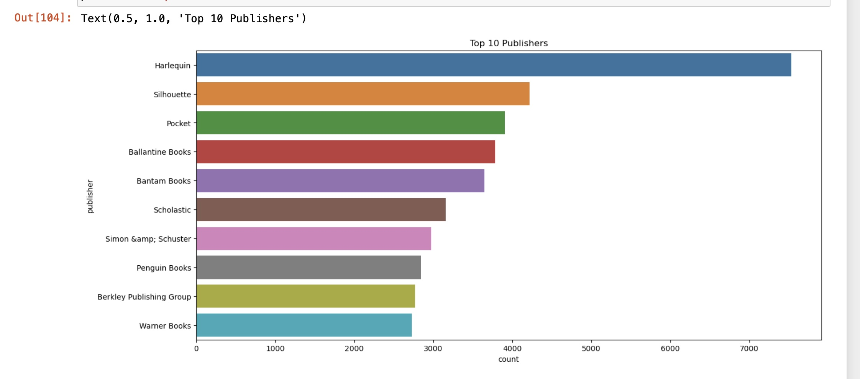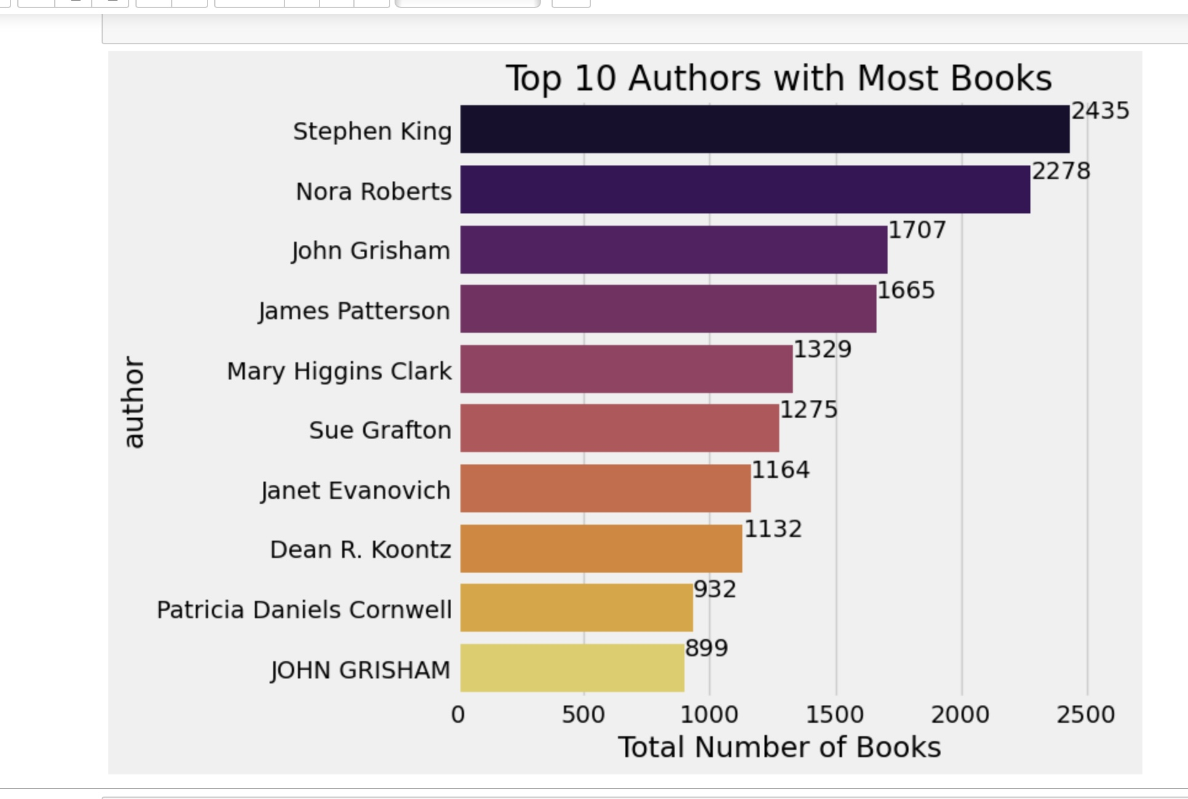ooks next to each bar for clarity, making it easy to see the exact number of books for each author. The plot shows the top 10 authors with the highest number of books in the dataset, providing insights into which authors are most prolific according to the data.

The plot shows the number of books from the top 10 publishers. Each bar represents a publisher, and the length of the bar indicates the number of books published by that publisher. This provides insights into the most prolific publishers in the dataset.

The plot shows the number of users from the top 10 locations. Each bar represents a country, and the length of the bar indicates the number of users 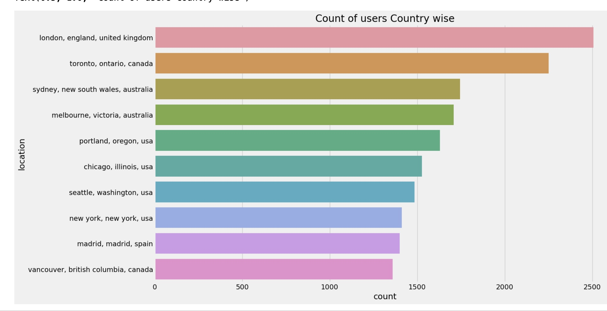from that country. This provides insights into the geographic distribution of users in the dataset.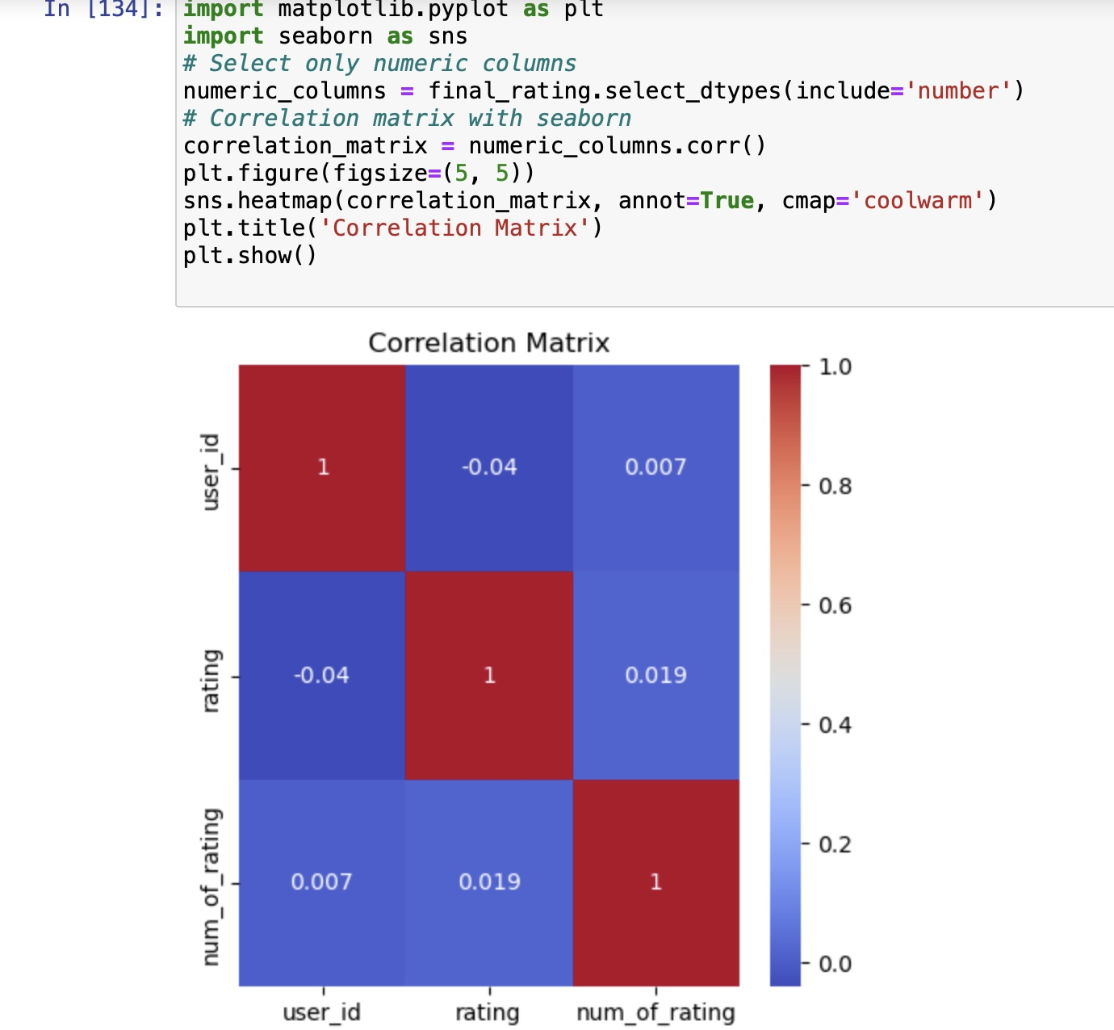

**Correlation Matrix:**

* 1: Perfect positive correlation: When one variable increases, the other variable also increases linearly.
* 0: No correlation: There is no linear relationship between the variables.
* -1: Perfect negative correlation: When one variable increases, the other variable decreases linearly.

**Scatter Plot of the correlation Matrix**

**4.4 Deployment**

# This is a streamlit web application that can recommend various kinds of similar books based on an user interest. By deploying the recommendation sScreenshot 2024-05-14 at 12.39.14 PM.jpegystem on Streamlit, users can access personalised book recommendations through a user-friendly web interface, enhancing their reading experiences and potentially increasing engagement with the platform.

pasted-image.tiff

Breakdown of Code: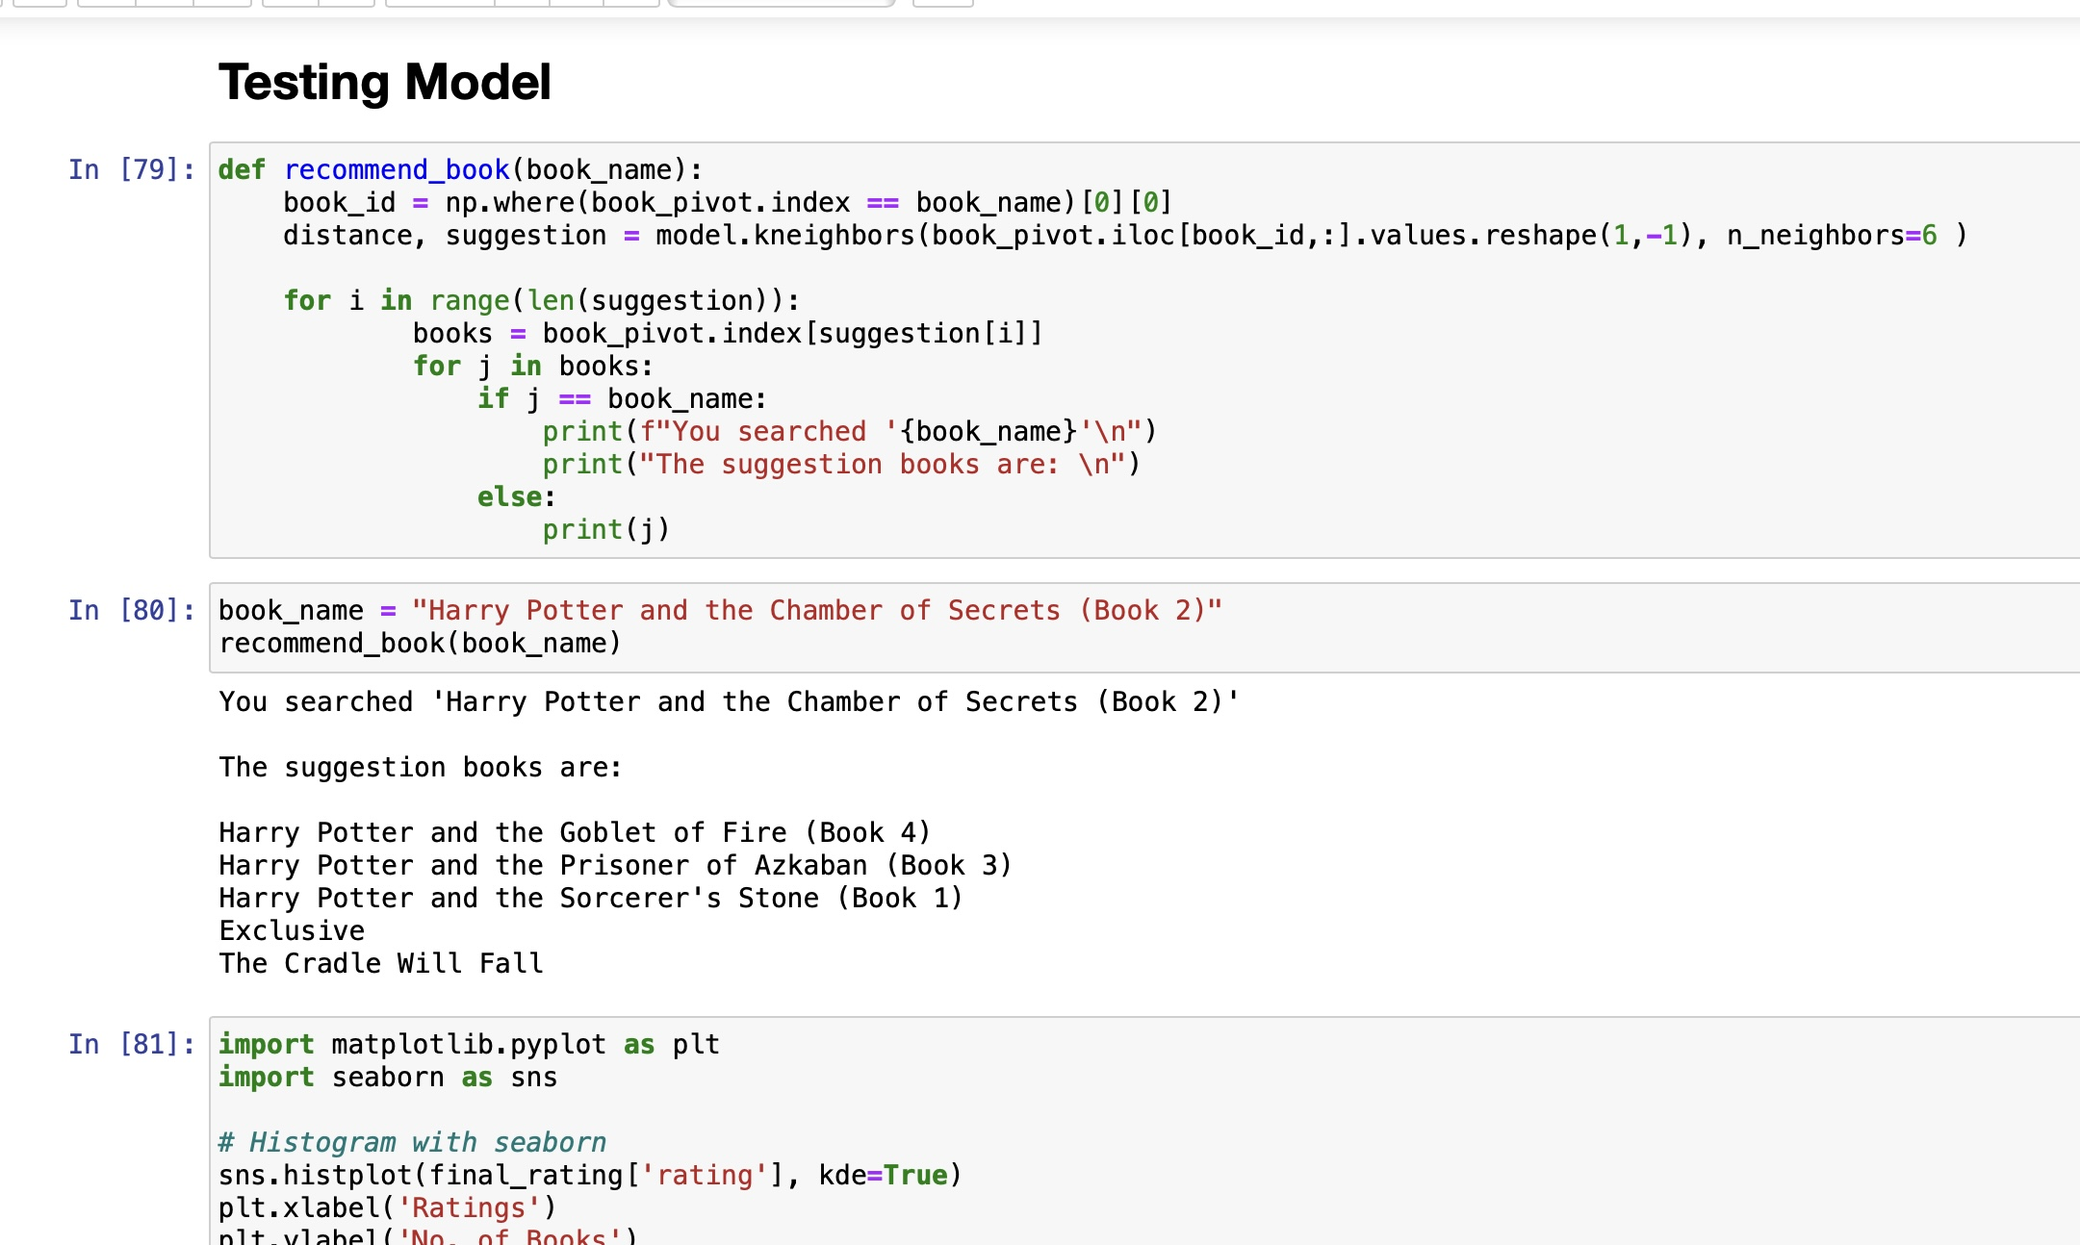

* The book_pivot is a pivot table where each row represents a book and each column represents a feature of that book.
* The function works on K Nearest Neighbours model that has already been trained on the data represented by book_pivot.
* This loop iterates through each suggestion and if the book name matches the searched book, it prints a header indicating the searched book and the suggested books based on the nearest neighbours of the given book name.

# pasted-movie.pngpasted-image.tiff

# 4.5 Conclusion

The project has been developed successfully, and the performance of the system has been found accurately. The system provides a platform to view similar recommended books to a book that the user has entered. The books are recommended to the users. The system is efficient in recommending similar book details, reduces the user's workload to know the number of similar books available, and keeps the readers open. This system saves the time of the user. Today as several books are available in the market, it only gets tedious for users to find books to their liking.

# 4.6 Future Scope

The New features could be added to this project to make this project more productive, reusable, and flexible, including adding new books to the database from time to time, ratings, and managing users. Recommendation systems are information filtering systems combined with customer and commercial applications. Recommender systems are a handy tool utilized to guide the selection process easier for users. The implemented book recommendation engine is an efficient system to recommend Books for e-users. It heavily relies on the ratings that the users gave to the recommendation engine. So, the fear whether the rating and feedback given is genuine or not lies a major issue to be solved yet.

4.7 REFERENCES

* <https://www.kaggle.com/datasets/ra4u12/bookrecommendation>
* <https://www.youtube.com/playlist?list=PLkz_y24mlSJa37r2xNDyEgt0Z4ilHtJ07>
* <https://www.youtube.com/playlist?list=PLkz_y24mlSJa37r2xNDyEgt0Z4ilHtJ07>
* <https://github.com/entbappy/Books-Recommender-System-Using-Machine-Learning>
* https://github.com/rajkrishna92/Machine-Leaning-projects-for-beginners/blob/main/12_Book Recommendation System.ipynb
* <https://github.com/syedsharin/Book-Recommendation-System-Project/blob/main/Book_Recommendation_System_Capstone_Project_4.ipynb>